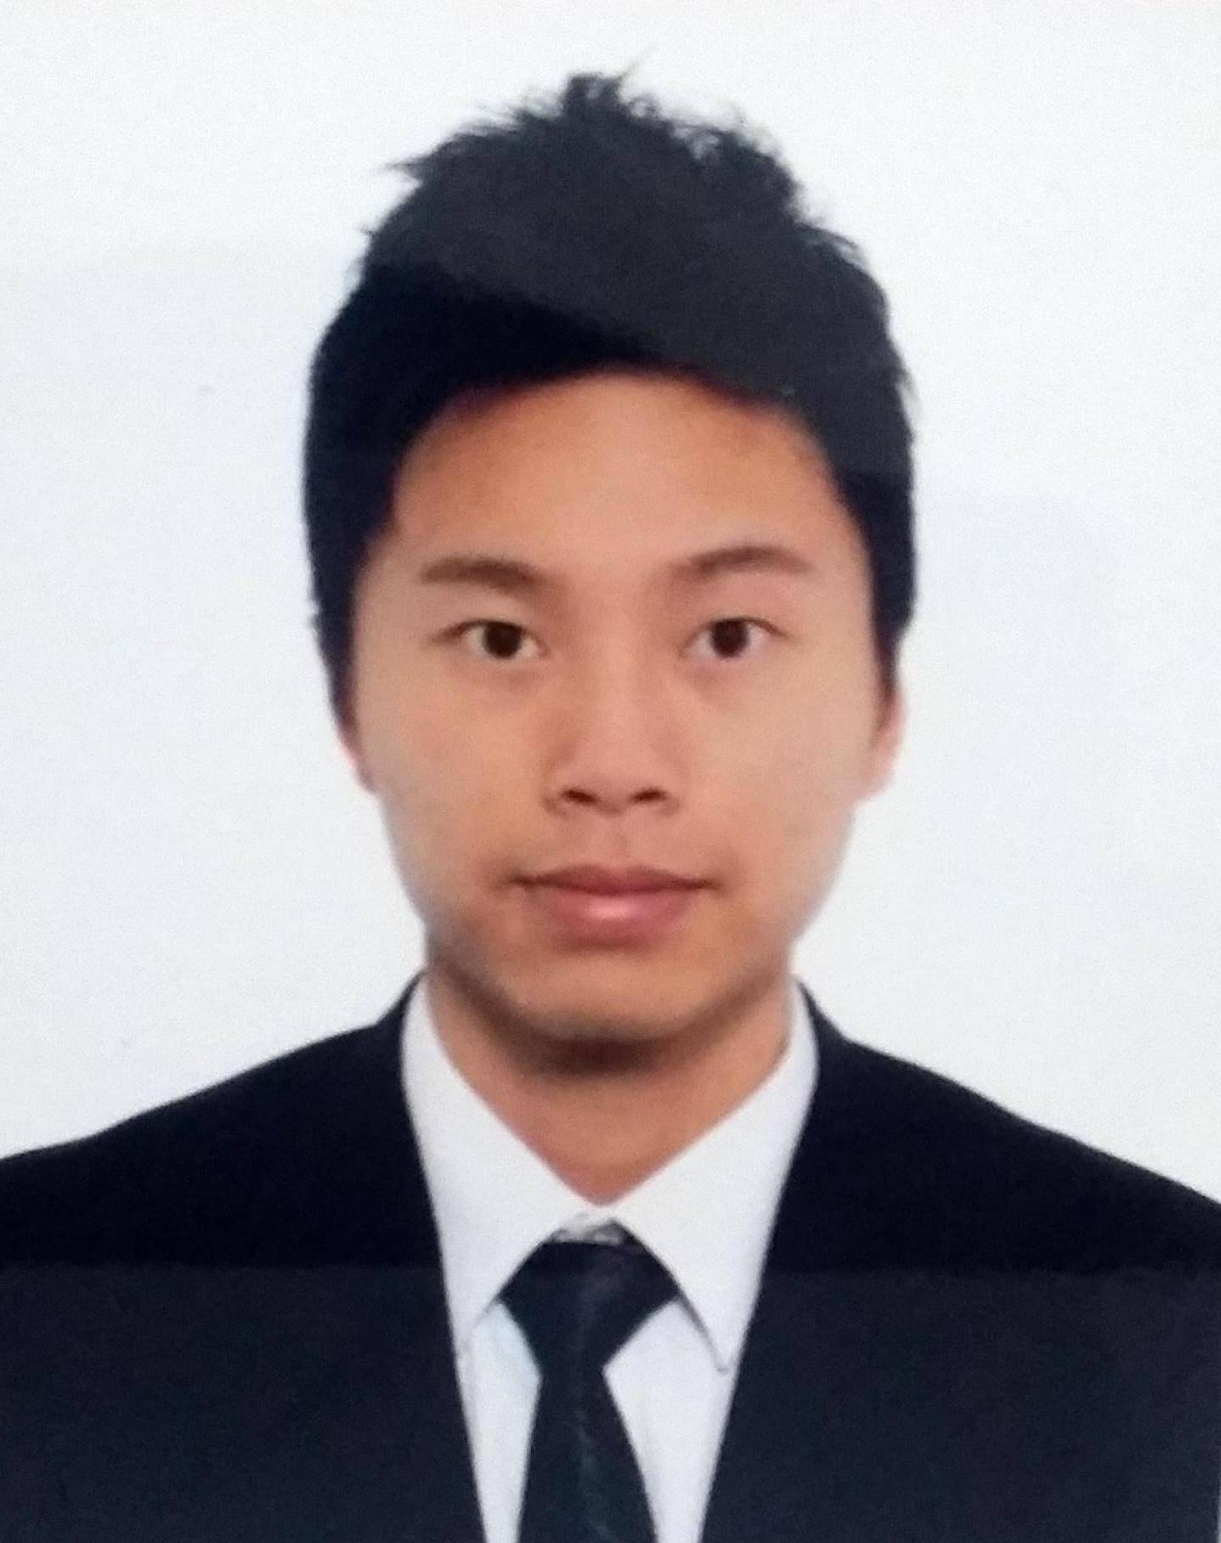

|  |  |  |  |  |
| --- | --- | --- | --- | --- |
| **Chinese name:** | 張焯然 |  | **English name:** | Cheung Cheuk Yin - Ryan |
| **Date of birth:** | 27th February, 1990 (27) |  | **Date available:** | Available now |
| **Place of birth:** | Hong Kong |  | **Expected salary:** | HKD 20,000 |
| **Nationality:** | Chinese |  | **Gender:** | Male |
| **Contact No.:** | 6537-3089 2357-0110 |  | **Contact email:** | [ryancheung1516@gmail.com](mailto:ryancheung1516@gmail.com) |

***EDUCATION***

* **Bachelor of Commerce- Major in Accounting 2009 - 2013**

*Macquarie University, Sydney*

* **Diploma of Commerce 2008 - 2009***Sydney Institute of Business and Technology, Sydney*
* **Certificate IV in University Foundation Studies 2007 - 2008**

*Sydney Institute of Business and Technology, Sydney*

***EMPLOYMENT HISTORY***

* **Swire Properties Working Period**  
  *Accountant Assistant April 2016 – Present*- Review accounting record regarding to trading properties on a timely basis  
  - Preparing financial statements and reports in accordance with statutory requirements  
  - Assist in tax filing for statutory companies  
  - Prepare management reports and variance analysis to support decision making   
  - Preparing quarterly forecast and 5 years budget for trading properties projects  
  - Assist in the preparation of the consolidated financial statement  
  - Liaise with various departments, banks and external auditors  
  - Handle ad hoc assignments
* **Aoba C.P.A. Limited Working Period**  
  *Audit Semi Senior February 2015 – March 2016*- meeting with client for company background review

- preparing audit field work in client office ( oversea )  
- perform stock take ( oversea )  
- providing financial report under HKICPA  
- leading team to complete job on schedule  
- providing tax computation services

* **Fortitude C.P.A. Limited Working Period**   
  *Audit Associate April 2014 – January 2015*- prepare audit field work in client office  
  - perform stock take  
  - provide financial report under HKICPA  
  - provide tax computation

***ASSOCIATE MEMBERSHIP***

* **CPA AUSTRALIA** **2014***Student associate*

***SKILLS***

* Available language: English, Cantonese, Mandarin, Korean
* Office work: Microsoft word, Excel, Power Point